Name: ________________________________ Date: ___________________________________

Class: _________________________________ Teacher: ___________________________________

# Math Mini Quiz 2

This Mini Quiz, we’re going to explore the math concepts that you’ve learned so far in this unit. This assignment should take you about **25 minutes**.

### Part 1 Jet Skis and Speedboats

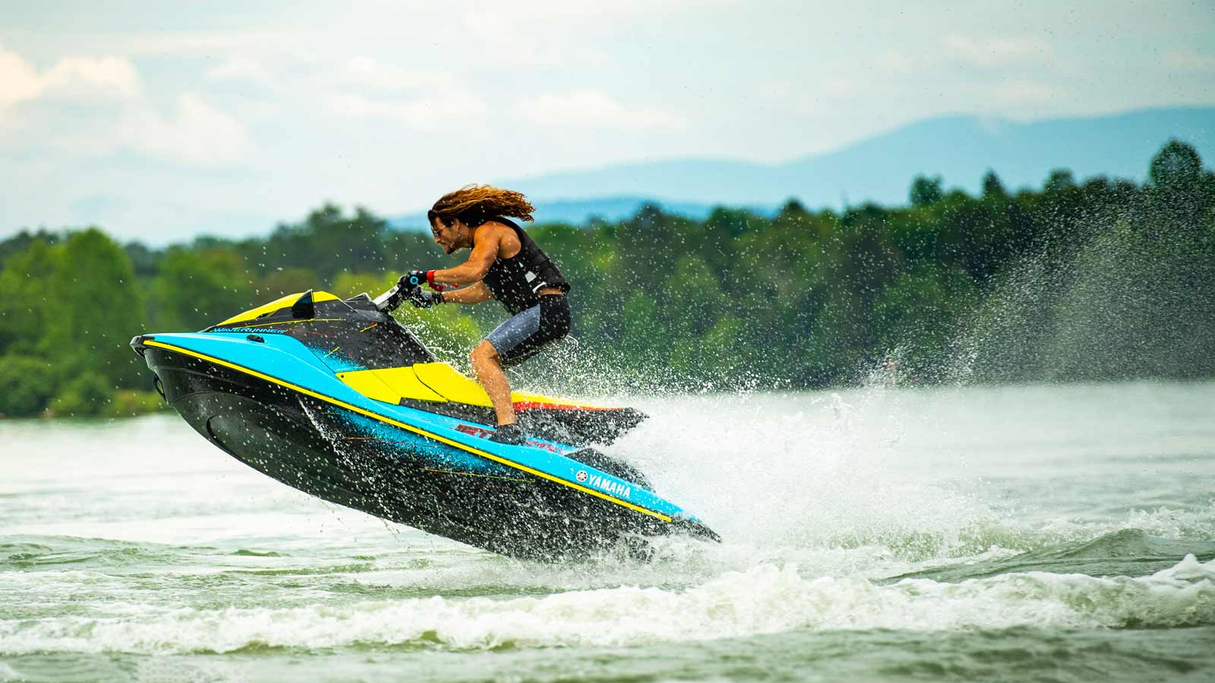

You are running a water sports center. Two of your most popular activities are the jetskis and the speedboat. However, to reduce the company’s carbon footprint, you’ve limited your company to 80 gallons of fuel per day. Each ride on the jetski (1 person) costs 8 gallons. Each speedboat ride (4 people) uses 20 gallons. The jetski and the speedboat trips take the same amount of time.

1) Express your constraint on fuel using ***j***, the number of jet ski rides, and ***s***, the number of speedboat rides.

*Answer: 8j + 20s ≤ 80*

2) On Monday morning, you have 4 jet ski rides scheduled. The rest of the day will be all speedboat rides. How many speed boat rides can you do on Monday?

*We plug in 4 for j to get:*

*8(4) + 20s = 32 + 20s ≤ 80*

*20s ≤ 80 - 32 = 48*

*s ≤ 48 / 20*

*s ≤ 2.4*

*This means max you can do 2 speedboat rides. Note that you cannot have 0.4 speedboat rides.*

3)You realize you forgot to write down how many of each ride were bought today.. However, you check the number of waivers, and you find out you had 7 customers. You also know that you used exactly 80 gallons of fuel today. How many of each ride did you do today?

*Fuel constraint: 8j + 20s = 80 Customer constraint j + s = 7*

*Solve the customer constraint for j: j = 7 - s*

*Plug into Fuel Constraint: 8(7 - s) + 20s = 56 - 8s + 20s = 56 + 12s= 80*

*Solve: 12s = 80 - 56 = 24 → s = 24 / 12 = 2*

*Plug in to get j → j = 7 - (2) = 5*

*So, there were j = 5 jet ski rides today and s = 2 speedboat rides today*

### Part 2 Graph Analysis

You’re on the varsity softball team. You’re on an away game and someone on your team’s baseball team comes to you and says they forgot to fill their water cooler! You tell them not to worry because you’re happy to share some of your water. You tell them to open the top of their cooler, which already had some water in it, and you start pouring some water into their cooler. As you pour, below are the graphs of the water in each cooler over time.

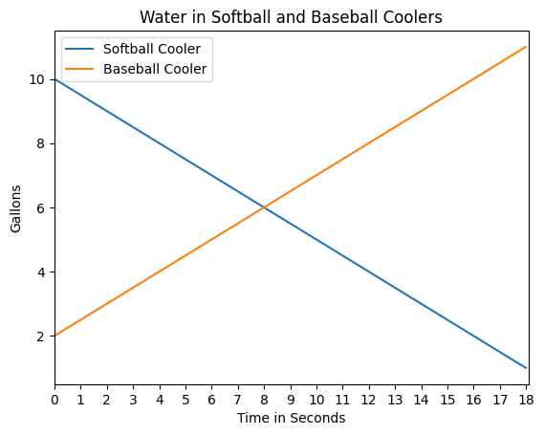

4) At what time do the coolers have an equal amount of water? How do you know?

*This will happen after 8 seconds. We know because the solution to a system of equations can be thought of as the point where the graphs intersect and they intersect at 8 seconds. We can also just see that both lines have the same value of 6 gallons at time 8 seconds.*

5) If each cooler has a capacity of 10 gallons, will the baseball team water cooler overflow or will the softball team run out of water first?

*The baseball cooler will overflow first. The baseball cooler overflowing would be represented by the orange line going higher than 10 gallons and the softball cooler would run out when the blue line hits zero. The orange line hits 10 fist, around 17 seconds.*

6) Decide how much water you would give to the baseball team (more than 0), and determine how long you should let the water flow from your cooler to theirs.

*Answer should account for the fact that the baseball team starts with 2 gallons. For example, if they say they’d give 2 gallons, they should give the time when the baseball cooler has 4 gallons.*